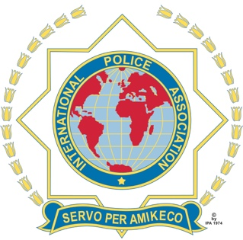**NCM 2022 BOOKING FORM**

**Friday 10th June to Sunday 12th June 2022**

***DOUBLETREE BY HILTON LINCOLN Brayford Wharf North, Lincoln, LN1 1YW***

**PLEASE ENSURE THAT YOU RETURN THE COMPLETED FORM AND**

**AMOUNT DUE TO SECTION UK**

***A booking form is required for each room booked.***

***Single rooms will be allocated on a first come first served basis***

|  |  |  |
| --- | --- | --- |
| **Full Name and Title** |  | |
| **NEC/Delegate/Observer/Guest** |  | |
| **Address in Full** |  | |
| **Contact Number** | **Home:** | **Mob**: |
| **Email address** |  | |
| **IPA Region** |  | **Member No** |
| **Room Type Required** | **Double / Twin / Single** | **Willing to share?** |
| **Accompanied by** |  | |
| **IPA Membership Details** |  | |
| **Address in Full** |  | |
| **Additional Nights required** |  | |
| **Special Requirements**  **i.e.) Dietary needs / Disability facilities/room type** |  | |
| **Flight details if applicable/** |  | |
| **Please indicate if you wish to join us on the afternoon trip on Friday:**  **Please indicate if you wish to join us on the day trip on Saturday:** | **International Bomber Command Yes No**  **Tour of Lincoln Castle & Cathedral Yes No** | |

Regional Treasurers please ensure all monies are transferred to Section HQ details as below:

A/C name: IPA Sort code: 54-21-47 Account No: 22097864 Reference will be your Surname/Region.

Full payment and completed forms are required before **1st APRIL 2022. After this date Regions are responsible for any changes/cancellations and costs incurred as a result.**

**Contact should be made if required with Section UK HQ to michele.rai@ipa-uk.org or The National Treasurer email at treasurer@ipa-uk.org**

**Prices**

Delegates & Observers £310

Non Delegate or Observer £280

Partners / Guests sharing £150

Extra Nights Thursday / Sunday B&B £109 B & B double occupancy

Informal Dinner on Fri night (only) £30/pp

Formal Dinner on Sat night (only) £30/pp